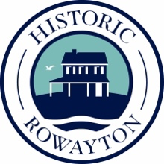

Historic Rowayton
Chili Cook-Off 2025 Entry Application
Name: _________________________________________________

If restaurant, contact name: _________________________________

Email: _________________________________________________

Telephone number: _______________________________________

Team name: ____________________________________________

Please return this form, along with the Norwalk Health Department application, to
Historic Rowayton, PO Box 106 Rowayton, CT 06853

See you on October 25th! Rain date is the 26th.

